

**Maratha Vidya Prasarak Samaj’s**

**K.R.T. Arts, B.H. Commerce & A.M. Science (K.T.H.M.) College, Nashik.**

**(2019-2020)**

**A PROJECT REPORT ON**

**“PIZZA XISHI”**

**FOR**

**VASUNDHARA VISION**

**Developed by**

**Yash Rajeshbhai Patel**

**M.Sc. (Computer Science)**

**Under the Guidance of**

**Prof. Mrs. K. D. More**

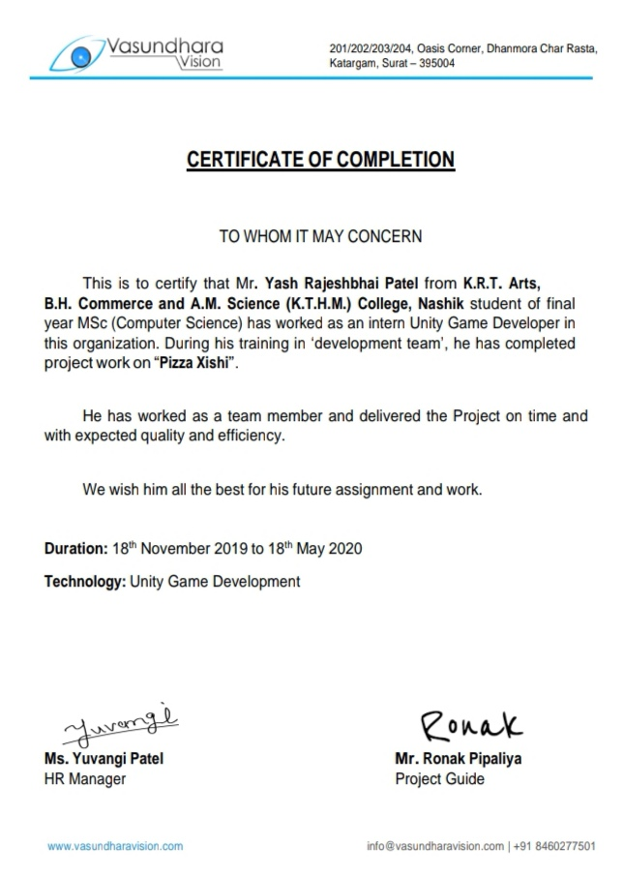

**INDEX**

|  |  |  |  |
| --- | --- | --- | --- |
| **TOPICS** | | | **PAGE NO** |
| 1. | ACKNOWLEDGEMENT | | 4 |
| 2. | COMPANY PROFILE | | 5 |
| 3. | INTRODUCTION OF PROJECT | | 6 |
| 4. | SYSTEM ANALYSIS | | 7 |
|  | 4.1 | WORKING OF EXISTING SYSTEM | 7 |
|  | 4.2 | OBJECTIVE OF PROPOSED SYSTEM | 7 |
| 5. | FEASIBILITY STUDY | | 8 |
| 6. | REQUIREMENT ANALYSIS | | 9 |
| 7. | HARDWARE & SOFTWARE REQUIREMENT | | 10 |
| 8. | MODULES IN PROPOSED SYSTEM | | 11 |
| 9. | DIAGRAM | | 12 |
|  | I. | E-R DIAGRAM | 13 |
|  | II. | CLASS DIAGRAM | 14 |
|  | III. | OBJECT DIAGRAM | 15 |
|  | IV. | USE CASE DIAGRAM | 16 |
|  | V. | ACTIVITY DIAGRAM | 17 |
|  | VI. | SEQUENCE DIAGRAM | 18 |
|  | VII. | COMPONENT DIAGRAM | 19 |
|  | VIII. | DEPLOYMENT DIAGRAM | 20 |
|  | IX. | COLLABORATION DIAGRAM | 21 |
| 10. | DATA DICTIONARY | | 22 |
| 11. | TEST PROCEDURE & IMPLEMENTATION | | 23 |
| 12. | USER INTERFACE (INPUT/OUTPUT SCREENS) | | 27 |
| 13. | LIMITATION & FUTURE ENHANCEMENT | | 33 |
| 14. | CONCLUSION | | 34 |
| 15. | BIBLIOGRAPHY | | 35 |

**1. ACKNOWLEDGEMENT: -**

With great pleasure, I would like to thanks all-important individuals in the development of

the project **"Pizza Xishi"**. However, it would not have been possible without the kind support and help of many; I would like to express my deep sense of gratitude towards all those who have played an individual and organization. I would like to extend my thanks to all of them.

I am highly indebted to the **VASUNDHARA VISION** and **Mr. Ronak Pipaliya** for their guidance and constant supervision as well as for providing necessary information regarding the project & also for their support in completing the project.

I wish to thank Prof. **Mrs. K. D. More** our project guide for helping, guiding us from time to time and cooperating with our tight office schedules throughout the project.

I wish to thank **Dr. Mr. M. N. Shelar** for giving opportunity and boosting our level of

confidence and making this project successful.

I would like to express my special gratitude and thanks to industry persons for giving me

such attention and time.

My thanks and appreciations also go to my colleagues in developing the project and people who have willingly helped me out with their abilities.

**2. COMPANY PROFILE: -VASUNDHARA VISION**

Vasundhara Vision is a well-established IT Company in Surat. We built our reputation on providing superior firmware technology, innovative software solutions.

Our company develops mobile applications like Android Development, iOS Development, Game Development and Web Design. Web Development, SEO Optimization, Logo Design, etc. for clients all over the world. We would like to offer our best services to you.

Our team includes professional mobile developers, professional designers, web developers,

professional game developers that focus on delivering high-quality code, design, functionality. user-friendliness in each app and all Services we take.

Each application and every service are customs made meaning it will be developed using the latest methods and technologies will be scalable to any point.

We have worked with clients for over 6 years. Some of our clients include Canada, USA, UK and many other countries.

Contact: +91 8460277501

Registered Office: 201/202/203/204, Oasis Corner,

Dhanmora Char Rasta, Katargam, Surat. (India)

Website: [https://vasundharavision.com](https://vasundharavision.com/)

**3. INTRODUCTION OF PROJECT: -**

Look at the real-time machine where pizza appears, let the xishi fall steadily into the middle of the pizza, let the pile of pizza piled up higher.

* **DESCRIPTION OF GAMEPLAY: -**

Let's jump on the pizza flying over from left to right. Continuous jump in the center of the pizza will be a perfect jump, multiple perfect jumps to improve scores, aim for higher targets and jump.

* **GAME FEATURES: -**

◆ fingertip cute game: -

Just move your fingers and get started easily. A wonderful mood and the rhythm of the xishi's beating challenge the perfect jump and higher scores.  
◆ Addictive magic gameplay: -  
Super cute animated sound, fun. Many perfect jumps, you can see the super-difficult performance of the pizza xishi.  
◆ Skin collection Pizza unlock: -  
Use the collected gold coins to buy pizza in the pizza shop, achieve the achievement to unlock the new pizza background, and experience the fun of collecting.

**4. SYSTEM ANALYSIS: -**

**4.1 WORKING OF EXISTING SYSTEM: -**

* The game is very big in memory, because of some extra feature.
* It takes lots of space in ram when the user starts the game.
* It has lots of animation at the time of jumps.
* It has lots of collections in shops for pizza & girls.
* Pizza speed is in some limit and sometimes it creates big random delays to generate itself.
  1. **OBJECTIVE OF PROPOSED SYSTEM: -**
* The game should support low-end devices & run smoothly.
* It has attractive animation with slow-motion & shining effects.
* It doesn’t have a shop with a girl skin.
* Pizza appears in perfect time & as you reach a higher score the speed of pizza will increase also.
* Added animated UI objects.

**5. FEASIBILITY STUDY: -**

At VASUNDHARA VISION, the feasibility analysis is designed to determine whether or not, given the project environment, the proposed project will be successful. It is useful to evaluate the cost and the benefit of the requested system. Feasibility study tries to anticipate future scenarios of development. The proposed system was reviewed considering three feasibility tests: -

**1. ECONOMIC FEASIBILITY: -**

Economic feasibility considers the cost/benefit analysis of the proposed project. The benefit is always expected to be overweighing the cost. The economic feasibility is helpful to find the system development cost and checks whether it is justifiable. For that it checks, investigation cost, software and hardware cost, training cost, salaries, Maintenance cost etc. The hardware/software setup required for the development and efficient operation of the system is already available. So, the cost incurred is less. The cost of developing the system is less than the benefits that will be provided by the proposed system. Hence the proposed system is economically feasible.

**2. TECHNICAL FEASIBILITY: -**

Technical feasibility center around the existing computer system (hardware,

software, etc.) and to what extent it can support the proposed addition. It checks whether the work for the project can be done with the current equipment, existing technologies, and available manpower.

**3. OPERATIONAL FEASIBILITY: -**

It is the measure of how well a proposed system solves the problems and takes advantage of opportunities identified during scope definition and how it satisfies the requirements identified in the requirement analysis phase of system development. It basically tells us that the proposed system is practically possible or not.

**6. REQUIREMENT ANALYSIS: -**

If the feasibility report is positive towards undertaking the project, the next phase starts with the gathering requirements from the users. Analysts and engineers communicate with the client and end-user to know their ideas on what the game should provide and which features they want the game to include.

Requirements Elicitation is the process to find out the requirements for the intended system by communicating with clients, end-users and others who have a stake in the system development.

There are various ways to discover the requirements.

**1. Questionnaires: -**

Questionnaires are much more informal, and they are good tools to gather requirements from stakeholders in remote locations or those who will have only minor input into the overall requirements. Questionnaires can also be used when you have to gather input from dozens, hundreds, thousands of people.

**2. Brainstorming: -**

On some projects, the requirements are not "uncovered" as much as they are discovered. In this type of project, simple brainstorming may be the starting point. The appropriate subject matter experts get into a room and start creatively brainstorming what the solutions might look like. After all the ideas are generated, the participants prioritize the ones they think are the best for this solution. The resulting consensus of best ideas is used for the initial requirements.

**3. Observation: -**

Team of experts visits the client's organization or workplace. They observe the workflow at client send and how execution problems are dealt with. The team itself draws some conclusions which aid to form requirements expected from the game.

**7. HARDWARE & SOFTWARE REQUIREMENTS: -**

* **Development Side: -**

**Hardware: -**

* OS: -macOS
* Processor: -Intel i5 or Higher
* Ram: - 8GB or Higher
* Memory: - 512GB SSD

**Software: -**

* Unity 3D
* Android Studio
* XCode
* Rider (JetBrains)
* **User Side: -**

**Hardware: -**

* OS: -Android/iOS
* Architecture: - ARM64/A7 or Higher
* CPU: -1.5 GHz or Higher
* RAM: - 2GB or Higher

**Software: -**

* Play Store/Apple Store to download

**8. MODULES IN PROPOSED SYSTEM: -**

In this system, we only consist of 1 **User** module.

* **User: -**

Here users can play the game & go to make a high score.

They can manage the settings of volume, vibration. They can set languages from the available list.

We have a shop in the game. And users can purchase an item of pizza from this shop.

If the user doesn’t have enough money to purchase an item from the shop then they can also purchase coins from the IAP (In-App Purchase) panel.

We Provide retry option with ads option if user loss & want to retry for the best high score.

**9. DIAGRAM: -**

1. **E-R DIAGRAM**
2. **CLASS DIAGRAM**
3. **OBJECTIVE DIAGRAM**
4. **USE CASE DIAGRAM**
5. **ACTIVITY DIAGRAM**
6. **SEQUENCE DIAGRAM**
7. **COMPONENT DIAGRAM**
8. **DEPLOYMENT DIAGRAM**
9. **COLLABORATION DIAGRAM**

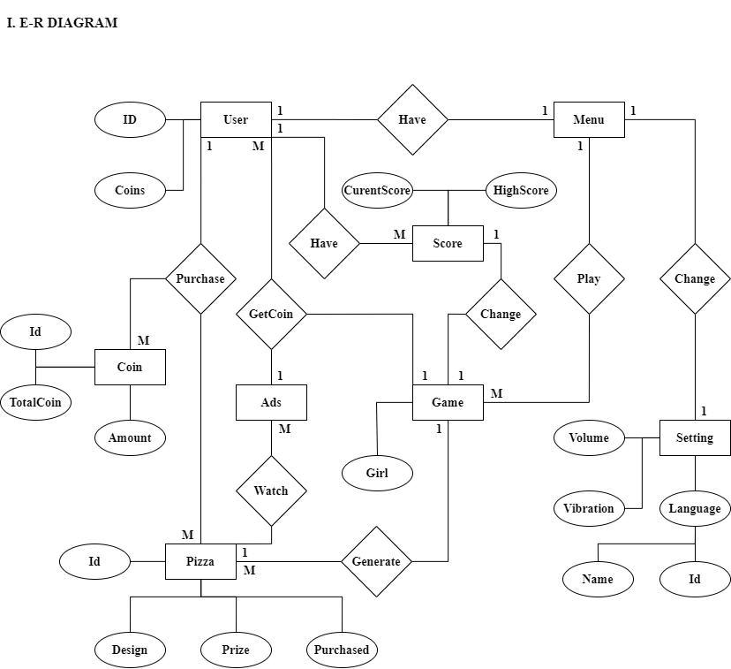

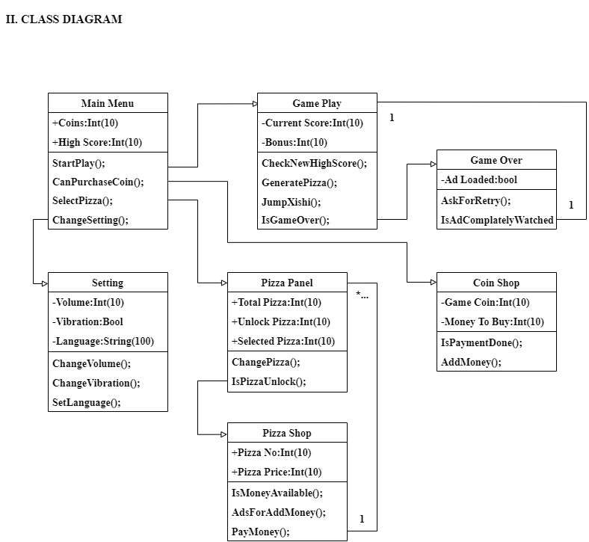

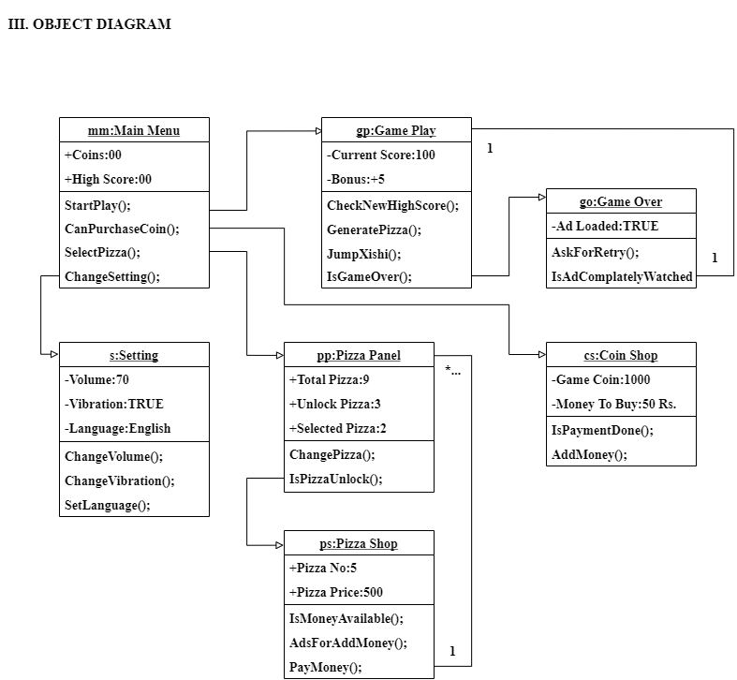

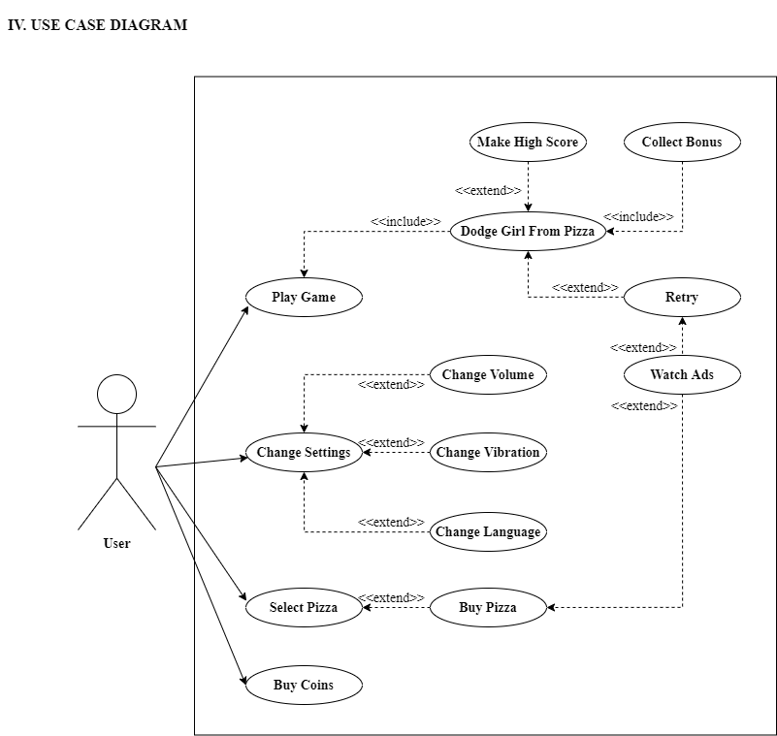

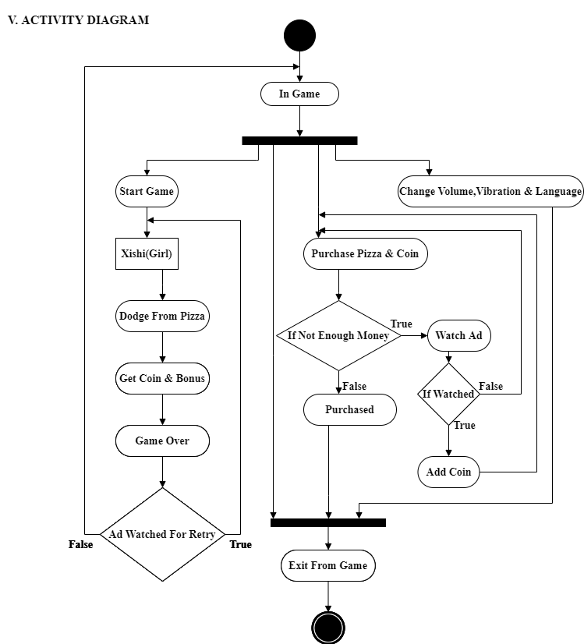

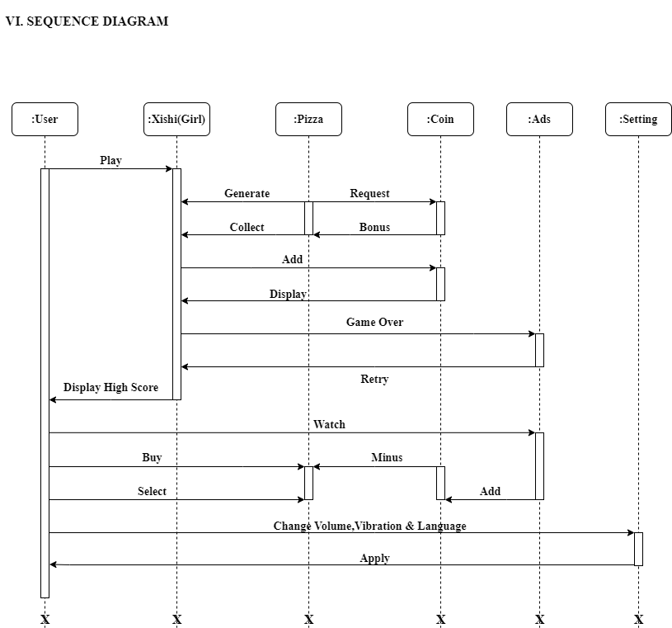

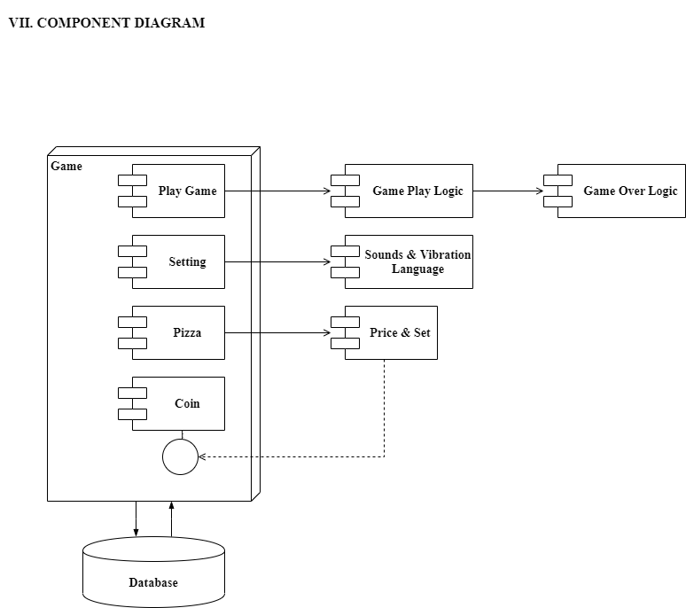

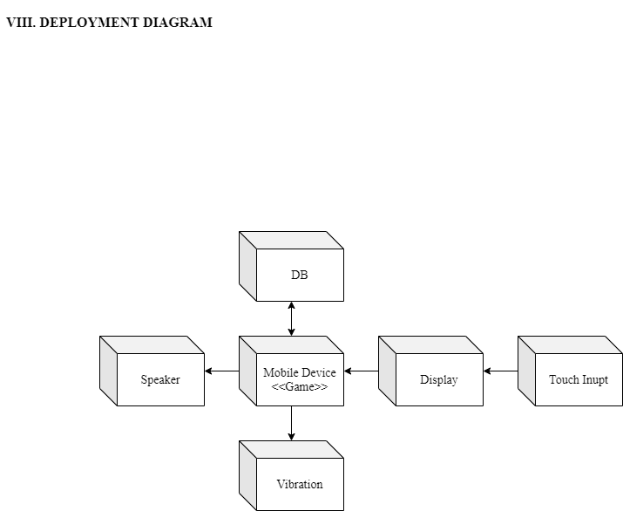

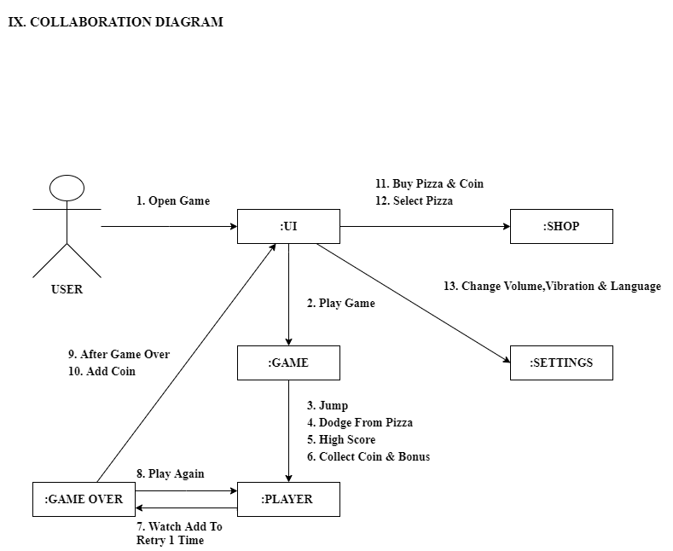

**10. DATA DICTIONARY: -**

|  |  |  |  |  |
| --- | --- | --- | --- | --- |
|  |  |  |  |  |
| **Player Model** |  |  |  |  |
|  |  |  |  |  |
| **Field** | **Type** | **Key** | **Extra** | **Null** |
| Id | Int (10) | Primary |  | No |
| HighScore | Int (10) |  |  | No |
| Coin | Int (10) |  |  | No |
| Volume | Float (10) |  |  | No |
| Vibration | Bool |  |  | No |
| LanguageNo | Int (10) |  |  | No |
|  |  |  |  |  |
|  |  |  |  |  |
| **Coin Model** |  |  |  |  |
|  |  |  |  |  |
| **Field** | **Type** | **Key** | **Extra** | **Null** |
| CoinId | Int (10) | Primary | Auto_increment | No |
| ReceivingAmount | Int (10) |  |  | No |
| Price | Int (10) |  |  | No |
|  |  |  |  |  |
|  |  |  |  |  |
| **Pizza Model** |  |  |  |  |
|  |  |  |  |  |
| **Field** | **Type** | **Key** | **Extra** | **Null** |
| PizzaId | Int (10) | Primary | Auto_increment | No |
| Design | Varchar (100) |  |  | No |
| Amount | Int (10) |  |  | No |
| Purchased | Bool |  |  | No |
| IsSelected | Bool |  |  | No |

**11. TEST PROCEDURE & IMPLEMENTATION: -**

|  |  |  |  |  |  |
| --- | --- | --- | --- | --- | --- |
|  |  |  |  |  |  |
| **ON INIT GAME:** | |  |  |  |  |
|  |  |  |  |  |  |
| **Tc-No** | **Tc-Name** | **Test Data** | **Expected Result** | **Actual Result** | **Status** |
| TCO1 | Hardware | Device hardware configurations | Match with requirement | Successfully match and install | Pass |
| TCO2 | Screen size | Display ratio (1080X1920) | Set UI fit  to screen | Successfully fit  to screen | Pass |
| TCO3 | Data/ Value | Default data (Coin-100, High Score-0, Volume-50, Vibration-off)/ Previous value (Anything) | Apply on game data & settings | Successfully applied | Pass |
| TCO4 | Audio sources | Address of files | Play music on various functionality | Successfully playing | Pass |
|  |  |  |  |  |  |
|  |  |  |  |  |  |
| **MAIN SCREEN:** | |  |  |  |  |
|  |  |  |  |  |  |
| **Tc-No** | **Tc-Name** | **Test Data** | **Expected Result** | **Actual Result** | **Status** |
| TCM1 | Animation | Animator values | Run animations | Successfully animating | Pass |
| TCM2 | Multi- Touch | Multiple finger inputs | Can't accept more than 1 touch | Accepting  single touch | Pass |
| TCM3 | Setting | Touch to setting | Open setting | Successfully open | Pass |
| TCM4 | Coin  shop | Touch to coin shop | Open coin shop | Successfully open | Pass |
| TCM5 | Pizza  shop | Touch to pizza shop | Open pizza | Successfully open | Pass |
| TCM6 | Play  game | Touch to start | Start game | Successfully start | Pass |
|  |  |  |  |  |  |
|  |  |  |  |  |  |
|  |  |  |  |  |  |
| **SETTING:** | |  |  |  |  |
|  |  |  |  |  |  |
| **Tc-No** | **Tc-Name** | **Test Data** | **Expected Result** | **Actual Result** | **Status** |
| TCS1 | Volume | Adjust slider point (100) | Change volume of game | Successfully changing | Pass |
| TCS2 | Vibration | Toggle button | Change state  of on/off | Successfully changing | Pass |
| TCS3 | Language | List of language | Show languages | Successfully open language | Pass |
| TCS4 | Close | Touch to close | Close setting | Successfully close | Pass |
|  |  |  |  |  |  |
|  |  |  |  |  |  |
|  |  |  |  |  |  |
|  |  |  |  |  |  |
|  |  |  |  |  |  |
| **LANGUAGE:** | |  |  |  |  |
|  |  |  |  |  |  |
| **Tc-No** | **Tc-Name** | **Test Data** | **Expected Result** | **Actual Result** | **Status** |
| TCL1 | Default | Get saved/ Default language | English/ (Other) | English | Pass |
| TCL2 | Switch/ Select | Select other language (Simple Chinese) | Save and apply changes on game | Successfully changed and saved | Pass |
| TCL3 | Close | Touch close | Close language | Successfully close and open setting | Pass |
|  |  |  |  |  |  |
|  |  |  |  |  |  |
|  |  |  |  |  |  |
|  |  |  |  |  |  |
|  |  |  |  |  |  |
| **COIN SHOP:** | |  |  |  |  |
|  |  |  |  |  |  |
| **Tc-No** | **Tc-Name** | **Test Data** | **Expected Result** | **Actual Result** | **Status** |
| TCC1 | Default | Get actual price for set of coins (already fixed) | List of coin set  with price (5 set) | Successfully get (5 set) | Pass |
|  |  |  |  |  |  |
|  |  |  |  |  |  |
| **PIZZA SHOP:** | |  |  |  |  |
|  |  |  |  |  |  |
| **Tc-No** | **Tc-Name** | **Test Data** | **Expected Result** | **Actual Result** | **Status** |
| TCP1 | Total Pizza | Get all pizza list | 9 pizza | 9 pizza | Pass |
| TCP2 | Current pizza | Default values (1)/ previous saved (3) | 3 | 3 | Pass |
| TCP3 | Select pizza | 5th pizza | Not purchased so  show suggestion to  purchase it first  then select it | Displayed message (go to pizza seller) | Pass |
| TCP3 | Purchase pizza | 5th pizza (500 Coin) | First check money if not enough to buy then reject else accept | Purchased | Pass |
| TCP4 | Ad video for money | "+50" | Watch complete video to add money | Watched and added money | Pass |
| TCP5 | Close | Touch close | Close pizza/seller | Successfully close | Pass |
|  |  |  |  |  |  |
|  |  |  |  |  |  |
|  |  |  |  |  |  |
|  |  |  |  |  |  |
|  |  |  |  |  |  |
|  |  |  |  |  |  |
|  |  |  |  |  |  |
|  |  |  |  |  |  |
|  |  |  |  |  |  |
|  |  |  |  |  |  |
|  |  |  |  |  |  |
|  |  |  |  |  |  |
|  |  |  |  |  |  |
|  |  |  |  |  |  |
|  |  |  |  |  |  |
|  |  |  |  |  |  |
|  |  |  |  |  |  |
|  |  |  |  |  |  |
|  |  |  |  |  |  |
|  |  |  |  |  |  |
|  |  |  |  |  |  |
|  |  |  |  |  |  |
|  |  |  |  |  |  |
| **GAME PLAY:** | |  |  |  |  |
|  |  |  |  |  |  |
| **Tc-No** | **Tc-Name** | **Test Data** | **Expected Result** | **Actual Result** | **Status** |
| TCG1 | Generate  pizza | From left/right side | From any side | From right side | Pass |
| TCG2 | Xishi Jump | Touch on screen | Jump animation of girl | Jumped successfully | Pass |
| TCG3 | Regeneration | From left/right side | From any side | From left side | Pass |
| TCG4 | Score | 1 jump=1 point | "+1" | 1 | Pass |
| TCG5 | Coin | if jump in middle of pizza =1 coin | "+1" | 1 | Pass |
| TCG6 | Bonus | It generates with pizza at any random time comes with it | "+5" | 6 | Pass |
| TCG7 | Speed | Increase speed of pizza generation after some gap of score | After 100 point pizza generating faster | Speed incremented | Pass |
| TCG8 | Game over | Check if current score > High score then ask for retry (watch full ad) then start game from  current state else go back to home panel | Ask for retry  and continue | Asked and successfully Continue | Pass |
| TCG9 | Game over animation | Pushed xishi to other  direction of pizza | open parachute then fall to the ground | Animated successfully | Pass |

**12. USER INTERFACE (I/O SCREENS): -**

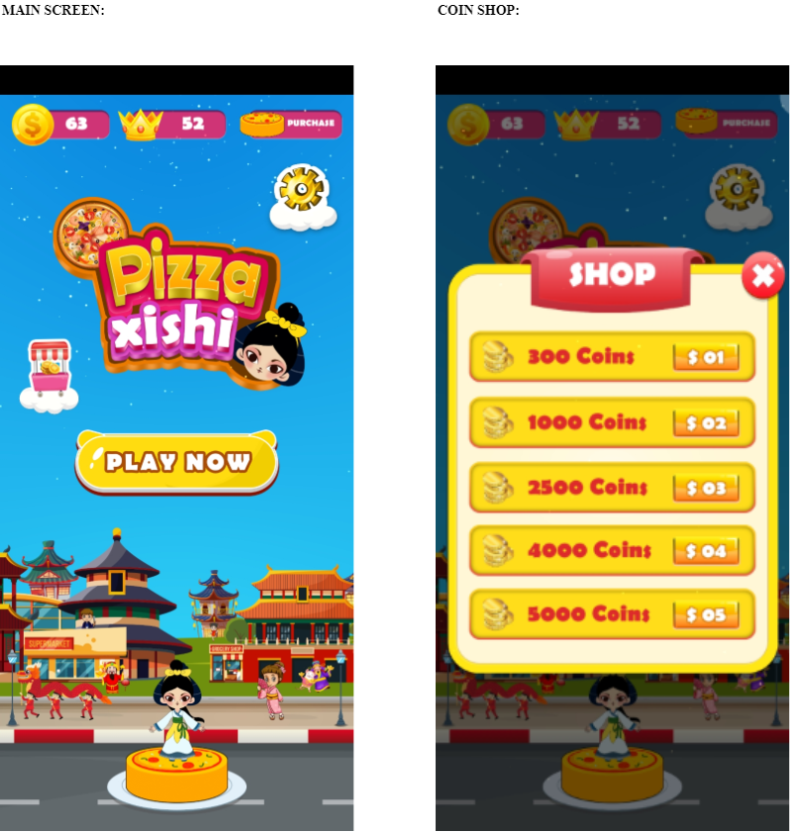

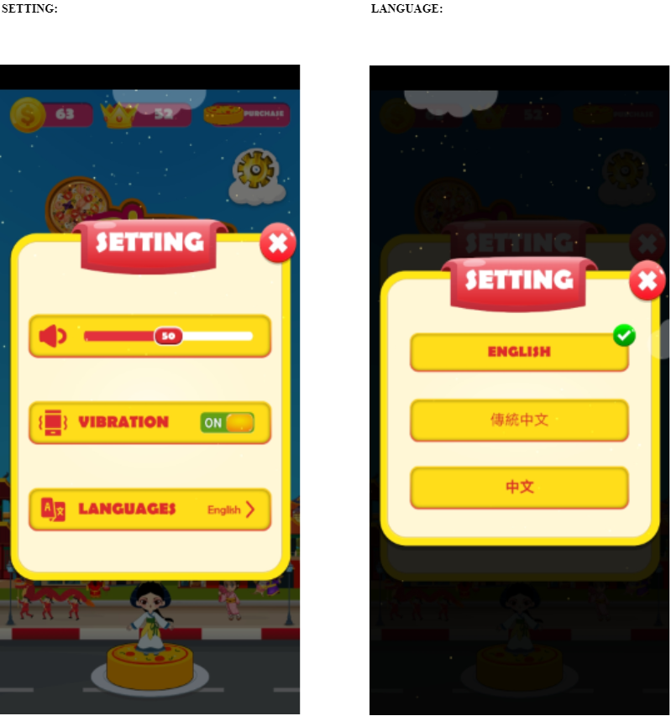

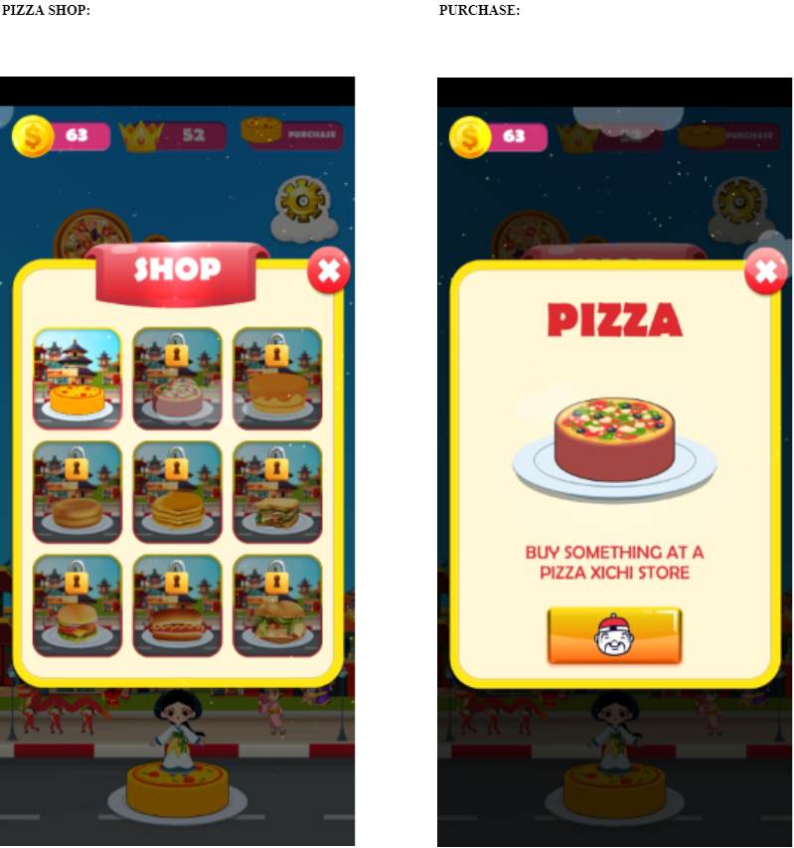

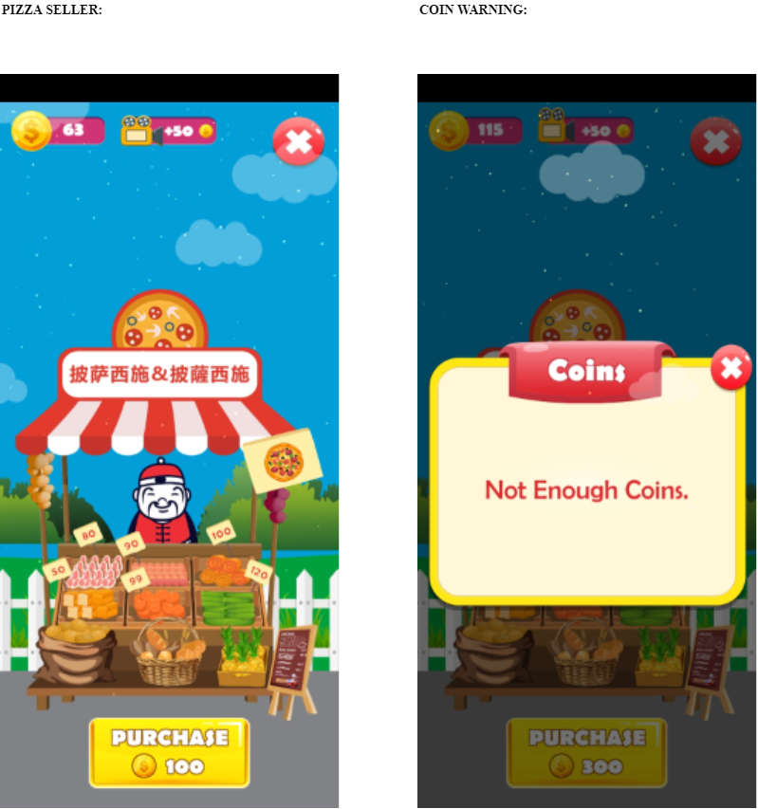

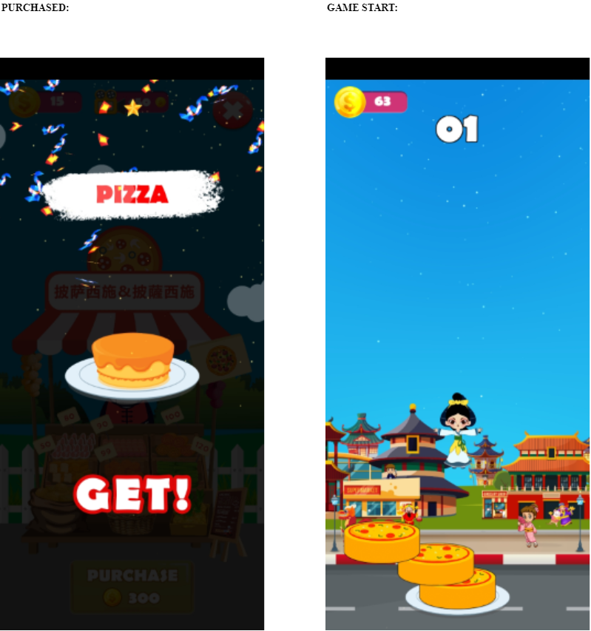

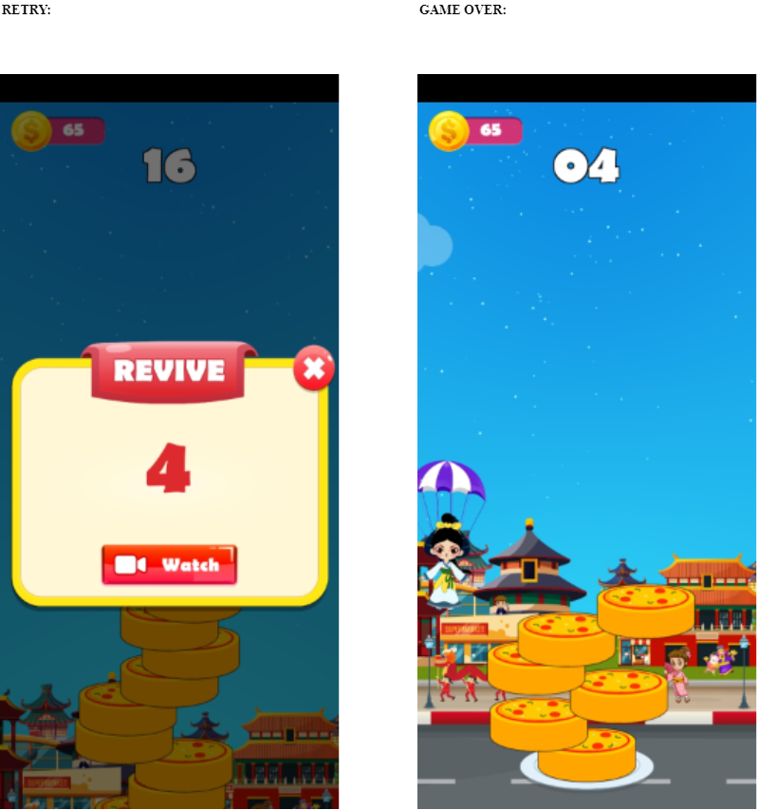

**13. LIMITATION AND FUTURE ENHANCEMENT: -**

* **DRAWBACKS:**
  + It can hack and easily throw any device.
  + If you reach some high amount of score and you try for retry, it is not going to work because of pizza speed you will lose immediately.
  + If you try to watch ads continuously in the seller panel you can get lots of money easily in less time and then you can buy any pizza or unlock all of them.
* **LIMITATIONS:**
  + Limited pizza design.
  + 1 normal fix background.
* **FUTURE ENHANCEMENT:**
  + We will add online user data saving with the use of the supported account.
  + We will add leaderboard data over the worldwide user, to create competition for the high score.
  + We will add the girl shop also with lots of new background for each girl.

**14. CONCLUSION: -**

We learned a lot through this project. This project has sharpened our concept of Game engine, animation and the software-hardware interface. We learned a lot about different documentation. The piece of software we developed is intended to serve the gamers of the world. The success of this project may give pleasure to billions of game lovers among the universe. This project not only tested our technical skills but also our temperament.

**15. BIBLIOGRAPHY: -**

**REFERENCE BOOKS:**

* Unity for Absolute Beginners
* Introduction to Game Programming Using C# and Unity 3D

**WEBSITES:**

* <https://docs.unity3d.com/Manual/index.html>
* <https://www.jetbrains.com/rider/documentation/>
* <https://hackr.io/tutorials/learn-unity>
* <https://www.youtube.com/user/Brackeys/featured>
* <https://answers.unity.com/index.html>